QUESTION 1:

Page once loaded:

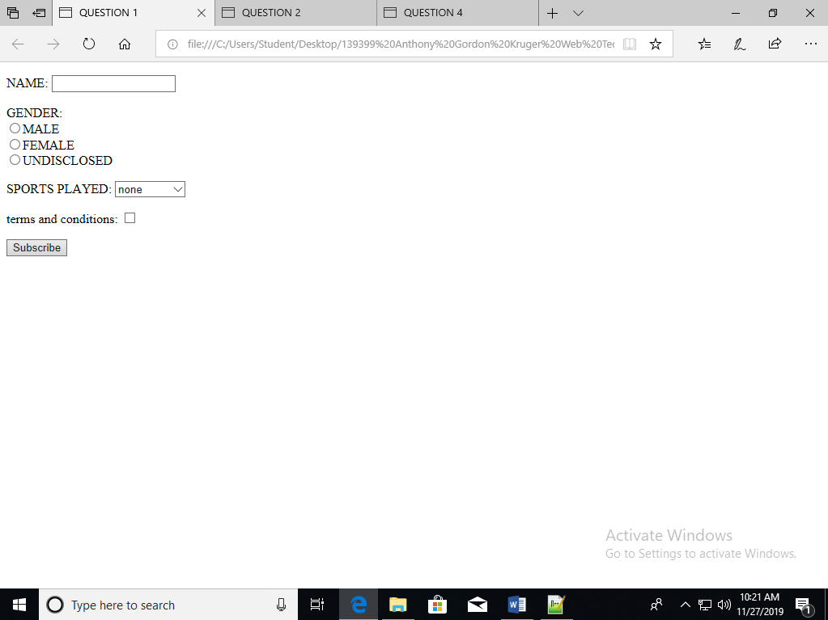

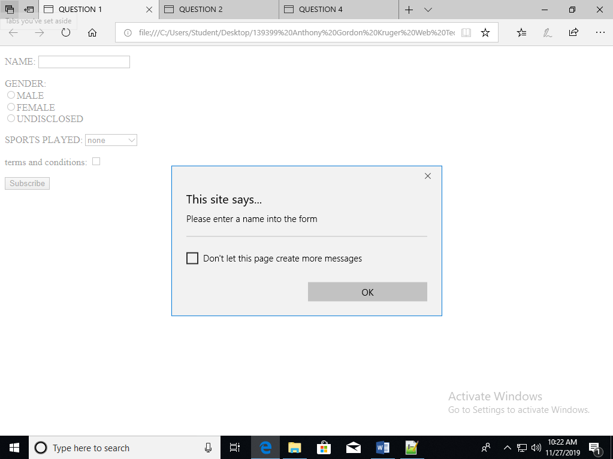

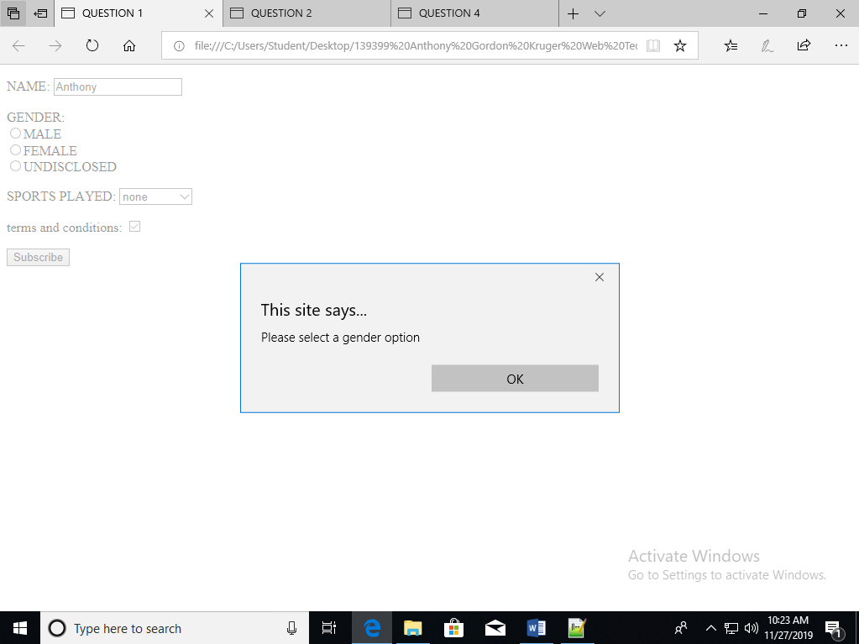

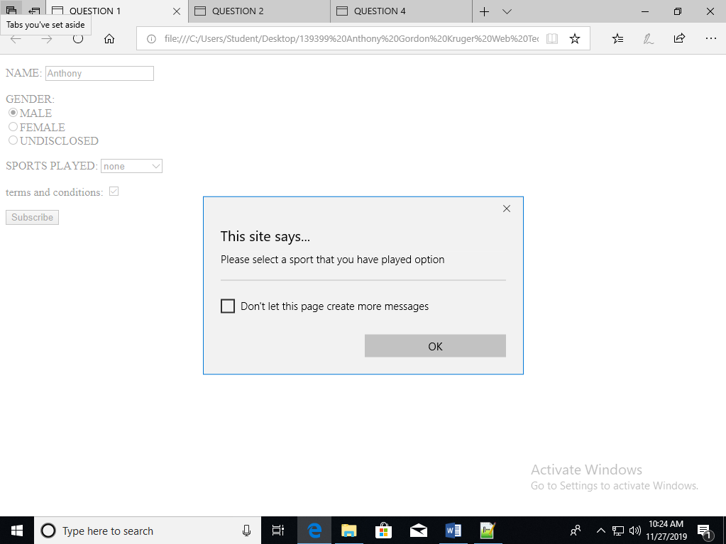

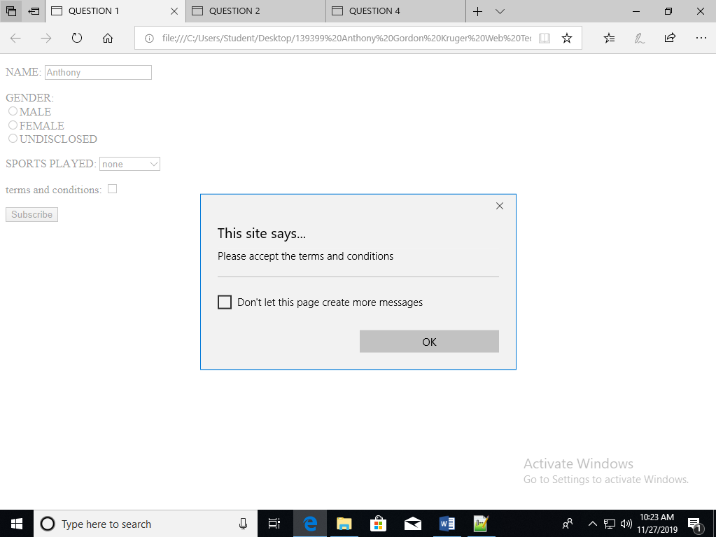

Source code:

<!DOCTYPE HTML>

<html>

<head>

<meta charset="UTF-8"/>

<title>

QUESTION 1

</title>

</head>

<body>

<form name="form1" action="">

<p id="NameBox">

NAME: <input type="text" id="Name" value=""/>

</p>

<p id="GenderGroup">

GENDER:<br/>

<input type="radio" class="gender" id="male" value="male"/>MALE<br/>

<input type="radio" class="gender" id="female" value="female"/>FEMALE<br/>

<input type="radio" class="gender" id="undisclosed" value="undisclosed"/>UNDISCLOSED<br/>

</p>

<p id="sportsPlayed">

SPORTS PLAYED:

<select>

<option id="none">none</option>

<option id="option1">OPTION 1</option>

<option id="option2">OPTION 2</option>

<option id="option3">OPTION 3</option>

<option id="option4">OPTION 4</option>

<option id="option5">OPTION 5</option>

<option id="option6">OPTION 6</option>

</select>

</p>

<p id="termsAndConditions">

terms and conditions: <input type="checkbox" id="termsAndConditionsBox"/>

</p>

<input type="Submit" value="Subscribe" onclick="Validate()">

</form>

<script type="text/javascript">

function Validate(){

if (document.getElementById("Name").value == ""){

window.alert("Please enter a name into the form");

document.getElementById("Name").focus();

return false;

} else if (document.getElementById("termsAndConditionsBox").checked == false ){

window.alert("Please accept the terms and conditions");

document.getElementById("termsAndConditionsBox").focus();

return false;

}else if (document.getElementById("male").checked == false ){

if (document.getElementById("female").checked == false ){

if (document.getElementById("undisclosed").checked == false ){

window.alert("Please select a gender option");

return false;

}

}

} else if (document.getElementById("option1").selected == false ){

if (document.getElementById("option2").selected == false ){

if (document.getElementById("option3").selected == false ){

if (document.getElementById("option4").selected == false ){

if (document.getElementById("option5").selected == false ){

if (document.getElementById("option6").selected == false ){

window.alert("Please select a sport that you have played option");

return false;

}

}

}

}

}

}

}

</script>

</body>

</html>

QUESTION 2:

Page once loaded:

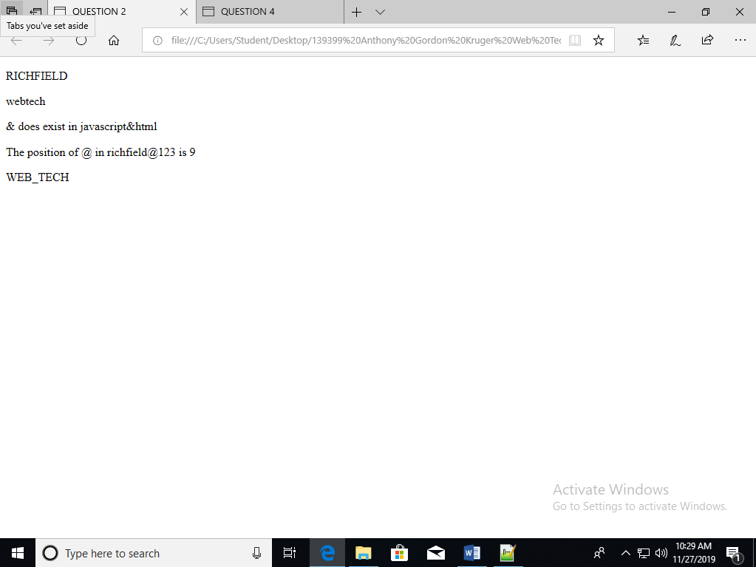

Source code:

<!DOCTYPE HTML>

<html>

<head>

<meta charset="UTF-8"/>

<title>

QUESTION 2

</title>

</head>

<body>

<p id="capitalize">

</p>

<p id="lowerCase">

</p>

<p id="doesExist">

</p>

<p id="PositionOf">

</p>

<p id="toJoin">

</p>

<script type="text/javascript">

var capitalize = "richfield";

var lowerCase = "WEBTECH";

var exist = "javascript&html";

var PositionOf = "richfield@123";

var toJoin = ["WEB","TECH"];

document.getElementById("capitalize").innerHTML = capitalize.toUpperCase();

document.getElementById("lowerCase").innerHTML = lowerCase.toLowerCase();

exist = exist.split("");

if (exist.indexOf("&") > 0){

document.getElementById("doesExist").innerHTML = "& does exist in javascript&html";

}

document.getElementById("PositionOf").innerHTML = "The position of @ in richfield@123 is " + PositionOf.indexOf("@");

document.getElementById("toJoin").innerHTML = toJoin.join("_");

</script>

</body>

</html>

QUESTION 3:

Page once loaded:

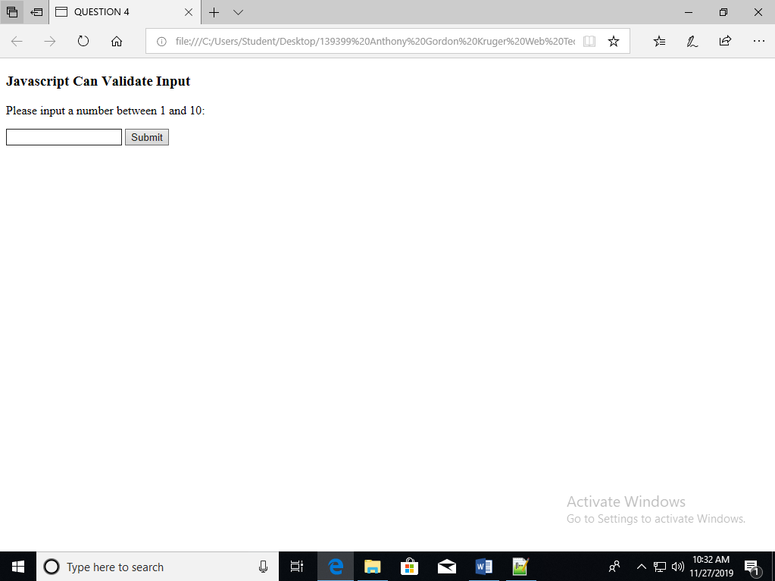

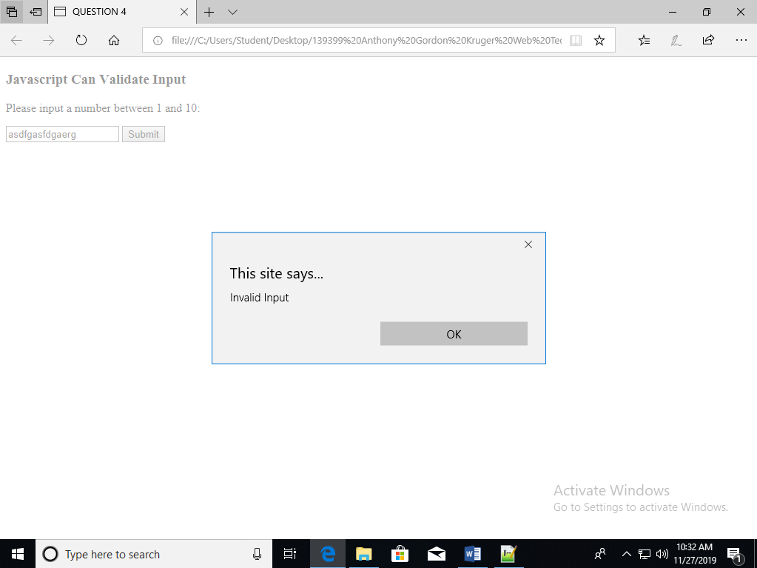

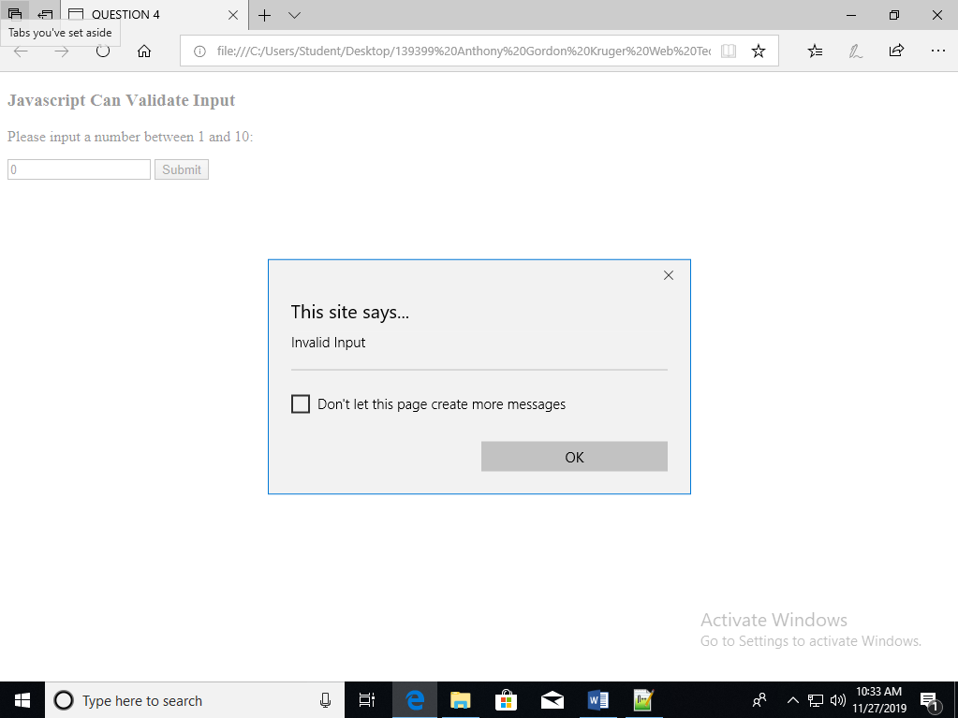

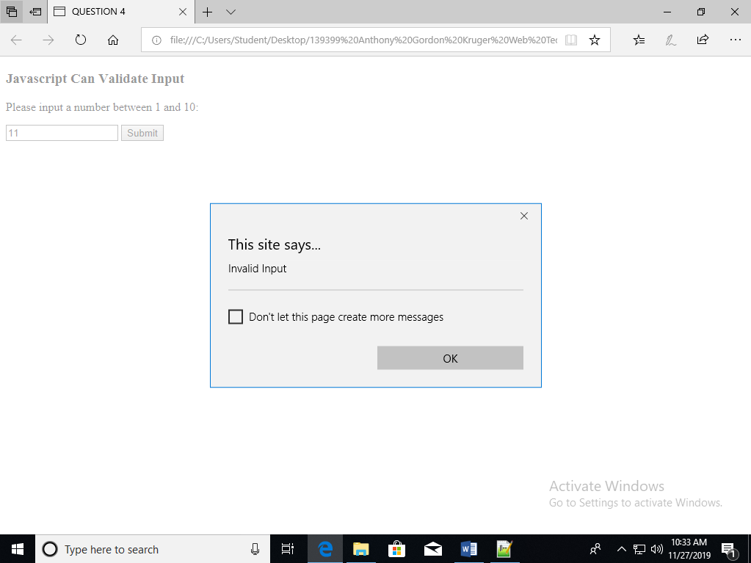

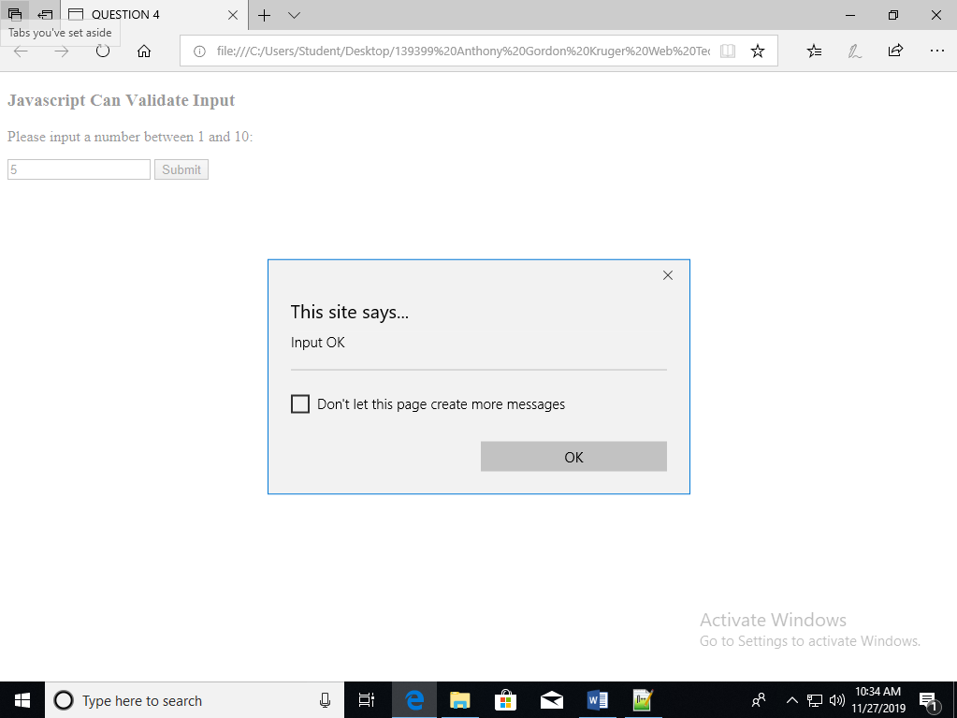

Source code:

<!DOCTYPE HTML>

<html>

<head>

<meta charset="UTF-8"/>

<title>

QUESTION 4

</title>

</head>

<body>

<div>

<h3>

Javascript Can Validate Input

</h3>

<p>

Please input a number between 1 and 10:

</p>

<input type="text" value="" id="input"/>

<button onclick="Validate()" id="Submit">Submit</button>

</div>

<script type="text/javascript">

function Validate(){

var input = document.getElementById("input").value;

if (!isNaN(input)){

input = parseInt(input);

if (input < 11){

if (input > 1){

window.alert("Input OK");

}else {

window.alert("Invalid Input");

}

} else {

window.alert("Invalid Input");

}

}else{

window.alert("Invalid Input");

}

}

</script>

</body>

</html>